**THAKUR POLYTECHNIC**

**Diploma in Information Technology**



**IF4I**

**THIRD SEMESTER [2023-2024]**

**GROUP NO -9**

**SUBJECT:JAVA Programming (22412)**

**TOPIC- Develop a Library Management Application.**

1. Manas Londhe 25

2. Rayyan Bhati 04

3. Anas Malkani 27

4. Anant Maurya 31

**Guided by: - Mrs. Suwarna Thakre**



**MAHARASHTRA STATE BOARD OF TECHNICAL EDUCATION**

This is to certify that the following group of students Roll.no **4,25,27,31** of **4th semester** of **Diploma** in **Information Technology** of the institute, **Thakur Polytechnic (Code:0522)** have completed the **Micro Project** satisfactorily in the subject **JAVA PROGRAMMING (22412)** for the academic year **2023-2024** as prescribed in the curriculum

PLACE: Mumbai Enrollment No: 2205220026

2205220048

2205220050

2205220054

**SEAL OF THE INSTITUTE**

**Subject Teacher Head of the Department Principal**

# ACKNOWLEDGEMENT

We feel immense pleasure in submitting this report and Java programming Codes about

**Library Management.**

While submitting this report, we avail this opportunity to express our gratitude to all those who helped us in completing this task.

Heading the list with our own honorable Principal

**Dr. S.M. Ganechari** who is the beginner of our inspiration. We owe our deep gratitude and very thankful to our guide

# and HOD **Mrs. Suwarna** **Thakre** who has proved to be more than just a mere guide to us. Apart from bringing to us what can be the joy of successful completion of this project was only possible due to her guidance and co-operation without which this work would never have been completed.

Finally, we wish to express our deep sense of respect and gratitude to every staff member who has helped us in many ways and also our parents who have always borne with us in any critical situation and to all others, sparing their time and helping us for completion of this project in whatever way they could. And lastly, we are grateful to each other the members of our group.

***THANK YOU.***

**PROPOSAL**

**MICRO PROJECT PROPOSAL**

1. **AIMS & BENEFITS OF THE PROJECT :-**

In the modern world of Information technology, JAVA PROGRAMMING has become the most preferred approach for software development. It offers a powerful way to cope up with the complexity of real-world problems. This course enables students to develop programs in 'JAVA' using JAVA Programming approach.

**2.0 Course Outcome Addressed –**

1. Develop programs using Object Oriented methodology in JAVA
2. Apply the concept of inheritance for code reusability

**3.0 Proposed Methodology** :-

A group discussion was held about the topic. After collecting relevant information, the main work of the project will start. Each member will be doing their allocated work. After completion of the work, every member will be presenting a presentation on the topic with an explanation and finally, the report will be submitted to the respective teacher

**4.0 ACTION PLAN:-**

|  |  |  |  |  |
| --- | --- | --- | --- | --- |
| **SR NO.** | **DETAILS OF THE ACTIVITY** | **PLANNED START DATE** | **PLANNED FINISHED**  **DATE** | **NAME OF RESPONSIBLE TEAM MEMBERS** |
| 1 | INFORMATION  SEARCH |  |  | ALL TEAM  MEMBERS |
| 2 | GROUP  DISCUSSION |  |  | ALL TEAM  MEMBERS |
| 3 | TAKING REFERENCES |  |  | ALL TEAM  MEMBERS |
| 4 | COMPILATION OF REPORTS |  |  | ALL TEAM  MEMBERS |
| 5 | REPORT  SUBMISSION |  |  | ALL TEAM  MEMBERS |

**5.0 RESOURCES REQUIRED:-**

|  |  |  |  |  |
| --- | --- | --- | --- | --- |
| SR.NO | NAME OF RESORCE | SPECIFICATION | QUANTITY | REMARK |
| 1 | Computer System | Windows 11 | 1 | AVAILABLE |
| 2 | Software | NOTEPAD ++ | 1 | AVAILABLE |
| 3 | Book | JAVA PROGRAMMING | 1 | AVAILABLE |
| 4 | Web Browser | Google Chrome | 1 | AVAILABLE |

**6.0 NAME OF TEAM MEMBERS:-**

Manas Londhe 25

Rayyan Bhati 04

Anas Malkani 27

Anant Maurya 31

**REPORT**

Micro-Project Report

**Title: Library Management System**

1. **Rationale:**

Java is a multi-platform, object-oriented, and network-centric language that can be used as a platform in itself. It is a fast, secure, reliable programming language for coding everything from mobile apps and enterprise software to big data applications and server-side technologies. Java is an extremely transferable programming language used across platforms and different types of devices, from smartphones to smart TVs. It's used for creating mobile and web apps, enterprise software, Internet of Things (IoT) devices, gaming, big data, distributed, and cloud-based applications among other types.

**2.0. Aim/ Benefits of the Micro project:**

* + Demonstrate the personal abilities and skills required to produce and present an extended piece of work.
  + Engage in personal inquiry, action, and reflection on specific topics and issues.
  + Focus on, and demonstrate an understanding of, the areas of interaction.
  + Reflect on learning and share knowledge, views, and opinions.

**3.0. Course Outcome Achieved:**

1. Develop programs using Object Oriented methodology in JAVA
2. Apply the concept of inheritance for code reusability

**4.0. Literature Review:**

**Library Management System where the user has the following options**

* Add Book Information
* Name, Author, Publisher , Price, Stock
* View Book Information
* Search to find Books of a given Author
* Exit from the Library

**5.0. Actual Methodology Followed:**

The Library Management System automates the basic library functions to aid in the day-to-day operations of a library. The purpose of the system is to allow for storing details of a large number of books and allow for add, borrow, return facilities separately to staff and students. Different privileges are given to different types of users.

The functions that the Library Management System provides are as follows:

**1.** **Insert:** This operation is performed when new data needs to be added to the system, for e.g., when a department purchases a new book, the book’s entry is inserted in the books database. This option has three choices:

a) Book: This choice allows entering data about newly purchased books into the books database. The data entered includes book’s author, title, publisher, cost and various other fields provided in the form. The data must be accurate and must be entered in the correct format as indicated in the forms.

**2. Display:** This is used to view each and every record, i.e., a record of every book, teacher, and student in the library.

a) Book: Record of every book, i.e., its accession number, author name, publisher name, etc.

**3. Search:** This function is used to search particular data from the database. This function can search for data related to all the

a) Book: To search for a particular book, to know whether it is currently available in the library or not. This can be done by entering a value in any one or more fields in the form to perform the search such as title or author name.

**4**. **Exit:** This takes user out of the application.

**6.0RESOURCES REQUIRED :-**

|  |  |  |  |  |
| --- | --- | --- | --- | --- |
| SR.NO | NAME OF RESORCE | SPECIFICATION | QUANTITY | REMARK |
| 1 | Computer System | Windows 11 | 1 | AVAILABLE |
| 2 | Software | NOTEPAD ++ | 1 | AVAILABLE |
| 3 | Book | JAVA PROGRAMMING | 1 | AVAILABLE |
| 4 | Web Browser | Google Chrome | 1 | AVAILABLE |

**7.0. Source Code:**

import java.util.ArrayList;

import java.util.Scanner;

class Book {

private String title;

private String author;

private boolean available;

public Book(String title, String author) {

this.title = title;

this.author = author;

this.available = true;

}

public String getTitle() {

return title;

}

public String getAuthor() {

return author;

}

public boolean isAvailable() {

return available;

}

public void setAvailable(boolean available) {

this.available = available;

}

}

class Library {

private ArrayList<Book> books;

public Library() {

this.books = new ArrayList<>();

}

public void addBook(Book book) {

books.add(book);

}

public void removeBook(Book book) {

books.remove(book);

}

public void displayAvailableBooks() {

System.out.println("Available Books:");

for (Book book : books) {

if (book.isAvailable()) {

System.out.println(book.getTitle() + " by " + book.getAuthor());

}

}

}

public Book findBook(String title) {

for (Book book : books) {

if (book.getTitle().equalsIgnoreCase(title) && book.isAvailable()) {

return book;

}

}

return null;

}

}

class LibraryManagementSystem {

public static void main(String[] args) {

Scanner scanner = new Scanner(System.in);

Library library = new Library();

library.addBook(new Book("Applied Science", "Scott Fitzgerald"));

library.addBook(new Book("Introduction to JAVA", "Harper Lee"));

library.addBook(new Book("1947", "Jawaharlal Nehru"));

while (true) {

System.out.println("\nLibrary Management System Menu:");

System.out.println("1. Display Available Books");

System.out.println("2. Borrow a Book");

System.out.println("3. Exit");

System.out.print("Enter your choice: ");

int choice = scanner.nextInt();

scanner.nextLine(); // Consume newline character

switch (choice) {

case 1:

library.displayAvailableBooks();

break;

case 2:

System.out.print("Enter the title of the book you want to borrow: ");

String title = scanner.nextLine();

Book foundBook = library.findBook(title);

if (foundBook != null) {

System.out.println("You have borrowed: " + foundBook.getTitle());

foundBook.setAvailable(false);

} else {

System.out.println("Sorry, the book is not available for borrowing.");

}

break;

case 3:

System.out.println("Exiting... Thank you for using the Library Management System!");

System.exit(0);

default:

System.out.println("Invalid choice. Please enter a valid option.");

}

}

}

}

**8.0. Outputs of the Micro Project:**

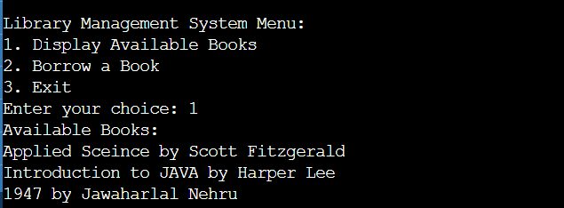

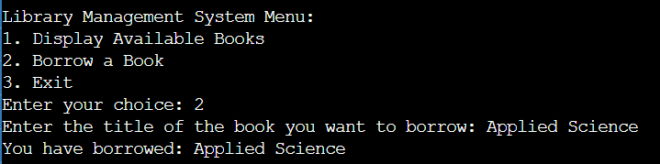

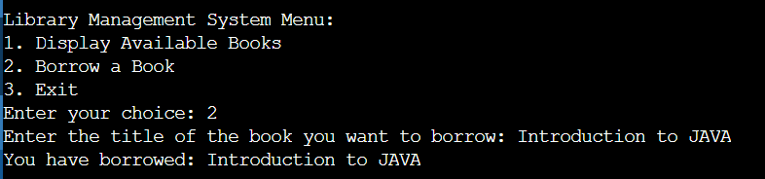

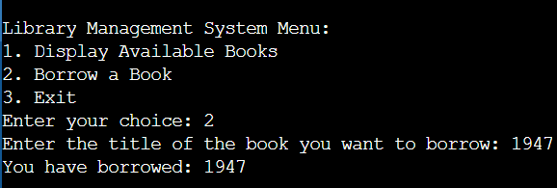

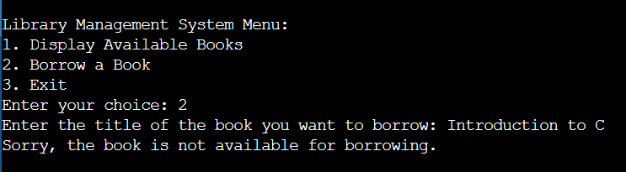

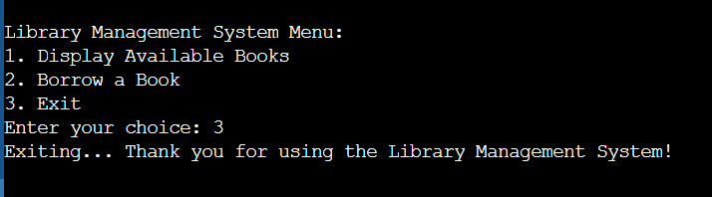

**9.0. Skill Developed/ Learning outcome of the Micro Project:**

In the complete duration of the micro-project, each of the team members has learned:

* About JAVA Programs.
* Assisting Library Management Application.
* Some Facts Classes and Objects, Inheritance, Constructor.

**10.0. Applications of the Micro Project:**

A) Using PC to learn about JAVA Programs Implementing.

B) Suggesting teammates Classes and Objects, Inheritance, Constructor.

C) How to efficiently use JAVA programming.